Ms. Freeman’s Science Wish list
August 2015
Hello KSA Family!

Ms. Freeman’s class is in need of some important science supplies that you may have lying around your home or that are fairly inexpensive!

I’d love to have your help to help stock our classroom so that we can have a year full of learning! In science!

Of course you don’t have to contribute, but please send any materials you may have that you can give with your students during anytime during the first two months of school
(Especially if you catch a GREAT back-to-school sale!).

Anything and Everything is appreciated in my class!

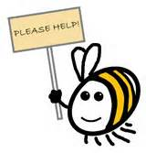
- Glue-Sticks
- Corn Syrup
- Baker’s Yeast
- Batteries (Either AA or AAA)
- Dixie Cups
- Iodine
- Turtle Food
- Paper Towels

Thanks!
Miss Jennifer Freeman
7th Grade Science Teacher
KIPP STRIVE Academy

